Titouan MAGNIN
Julien OUDOT
Titouan NICOT

eCasques company

Business Plan

CONFIDENTIAL
[25/04/2022]
Table of content
1 Summary 3
2 The company 3
3 Products and services 3
4 Market research 4
4.1 Concurrents and market segmentation 4
5 The stragegy 5
5.1 Project’s Goal 5
5.2 Fidelity programm 5
6 Financial plan 5
6.1 Sales record 5
6.2 Project’s Cost 5
6.3 Sales previsions 6

Summary
The eCasques company is a new player in the helmet market. We sell many types of helmets from protection helemet to headphones since 2017.
The company sells its helmets to many customers, from compagnies to regular customers, in its shops.
As of 2022, we have earned 5 millions euros in sales and this number is growing steadily since 2019.
Our new project involves the creation of a website to advertise our helmets. Since the online market is barely used by the company, it would be profitable quite fast. We are in the search of 200 000 euros to create this site.

The company
As said before, the eCasques company sells all kinds of helmets since June 2017. It was created after the fateful vacation in Brazil of the two co-founders.
The first selling point created was in Belfort, the birthplace of the company, soon followed by other shops in Lyon and Dijon the following year.
In 2019, a website was created by the company to boost sales. However, the client side of the website, where the client could buy helmets, was not correctly implemented. As a result, the company didn’t take advantage of the online market.
The company is currently ruled by the two co-founders : Julien O and Titouan M. There are 5 employees working at eCasques such Titouan N.
The company has shareholders, as it is an anonymous society.

Products and services
At eCasques, we sell all kinds of helmets such as the prussian helmet or the gamer headphone.
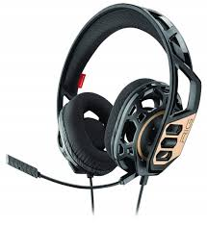Figure 1: Gamer headphone
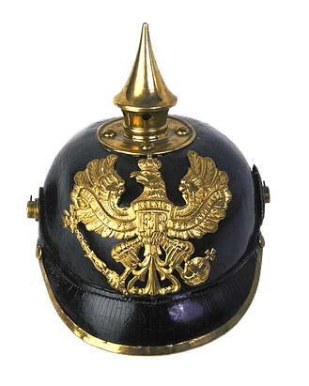Figure 2: Prussian helmet

We also have various clients, such as private compagnies, students or just people that happen to pass by our physical shops. Our clients are mostly buying from our physical selling points. For this reason, our clients are mostly native to Belfort, Dijon and Lyon.
However, we currently aim to sell our helmets to younger people (18 to 25 years old) who buy on Internet. This is why we have to create a new website.
We use warehouses to store our helmets. So when a store needs a certain type of helmet, trucks are sent out to fill their inventory.

Market research

Concurrents and market segmentation
The concurrents of our company are various. Aside from the major firms which sell various items including helmets, such as Amazon, there are multiple firms that specialize in the selling of helmets, such as iCasque : (https://www.icasque.com/) and Centrale du casque : (https://www.centrale-du-casque.com/).
In the chart below, eCasques is represented in brown with the key numbers of the old website.
Figure 3: Helmet Market Segmentation
As it can be seen, eCasques is not the best helmet seller in the market, but it is mostly because we don’t benefit yet from the online helmet market. The new website would allow us to attract more customers.

The stragegy

Project’s Goal
The project consists in creating a new website for the company. The current website doesn’t have a fonctionning client side. This makes it almost impossible to correctly buy helmets online. Thus, it closes to us the opportunity to use the online market.
The goal of the new website is to help us achieve better sales results by permitting clients to buy helmets online. The online market not being well used by the company, the creation of the new website would allow use to make our sales rise up fast.

Fidelity programm
To try to outperform our concurrents, eCasques put in place a fidelity program in 2021.
This program consists in giving free tests of new helmets and free reductions to regular customers. Customers are also given a free reduction for their first pruchase, to try and make them come back.

Financial plan

Sales record
The company has a sales record of 5 millions euros as of 2022. It is in constant growth since 2019.
The chart helps us see that our company is making profits quite fast.
Figure 4: Sales records since the creation of eCasques

Project’s Cost
The initial budget given by the company responsible for making the new website is of 200 000 euros.
The amount of money required is explained by the cost of buying and maintaining the working place of the company. The employees also have to be paid and provided with functionning computers to make the website. Finally, a server has to be brought and maintained to create the website, as it is going to be stored on it.

Sales previsions
The fact that the online market is not used much by the company will allow us to try and conquer a new market. This could help us increase our sales records.
It is estimated that it would require at least two year to see the results of the new website.

Figure 5: Predicted sales records

